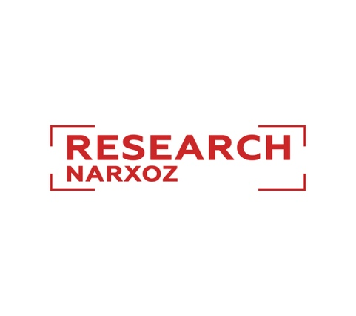

Student Research Conference 2020

Dear students of Narxoz University!

We are pleased to announce a call for papers for the student research conference.
The conference is open to Narxoz students of bachelor and master programs.

Thematic sections:

- Economics and finance
- Management and Entrepreneurship
- Public Policy and Law
- Society and Regional studies
- Ecology and Sustainability

Requirements:
Submissions need to be sent to student.research.club01@gmail.com
All papers will go through a blind review process.
Fill-out the cover page as well*

Details:
Research paper (2,000-word limit)
Minimum 14 references
Times New Roman, 12 font, 1.5. spacing
Working languages: Kazakh, Russian, and English
Abstract (in three languages) – 150 words maximum each

Dates:
The deadline for sending papers is March 27th, 2020

The conference will be held on April 22nd, 2020

After the conference, selected papers will be published in the conference proceedings

For questions please contact
ari@narxoz.kz

Cover page*

Author’s full name

Paper title

Program

Year of study

Email

Phone

