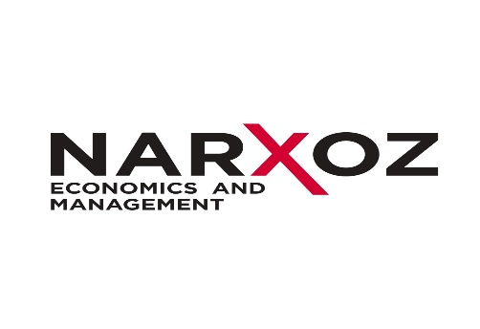
MA in Tourism and Hospitality
(professional track – 1.5 years)

PROGRAM DETAILS AND CURRICULUM
Specific course requirements for the MA in Tourism and Hospitality program are as follows:
Courses | Credits (ECTS)
General courses | 10
Specialization courses | 38
Internship and research | 42
Total | 90

General courses

Courses | Credits (ECTS)
English | 1
Management | 2
Management psychology | 3
Research Methods | 4
Total | 10

Specialization courses

Courses | Credits (ECTS)
Financial management in tourism and hospitality | 5
Organizational strategy of tourism and hospitality | 6
Tourism and hospitality products concepts | 6
Service quality management in tourism and hospitality | 6
Lux management in tourism and hospitality | 5
Operations management in tourism and hospitality | 5
Strategic marketing in tourism and hospitality | 5
Total | 38

Internship and research

Courses | Credits (ECTS)
Industry internship | 12
Research | 18
Thesis and thesis defense | 12
Total | 42

