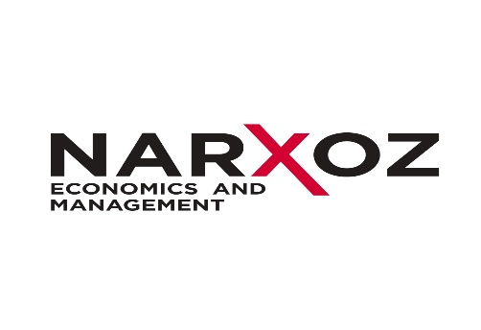
MSc in Restaurant and Hotel Business
(scientific-pedagogical track – 2 years)

PROGRAM DETAILS AND CURRICULUM
Specific course requirements for the MSc in Restaurant and Hotel Business program are as follows:
Courses | Credits (ECTS)
Scientific-pedagogical core | 22
Specialization courses | 46
Internship and research | 52
Total | 120

Scientific-pedagogical core

Courses | Credits (ECTS)
History and philosophy of science | 4
High school pedagogy | 3
English | 5
Management psychology | 5
Research Methods | 5
Total | 22

Specialization courses

Courses | Credits (ECTS)
Financial management in tourism and hospitality | 5
Strategic marketing in tourism and hospitality | 5
Organizational strategy of tourism and hospitality | 6
Tourism and hospitality products concepts | 6
Service quality management in tourism and hospitality | 6
Lux management in tourism and hospitality | 6
Operations management in tourism and hospitality | 6
Technology and innovations in tourism and hospitality | 6
Total | 46

Internship and research

Courses | Credits (ECTS)
Internship | 16
Pedagogical internship | 3
Research internship | 13
Research | 24
Thesis and thesis defense | 12
Total | 52

